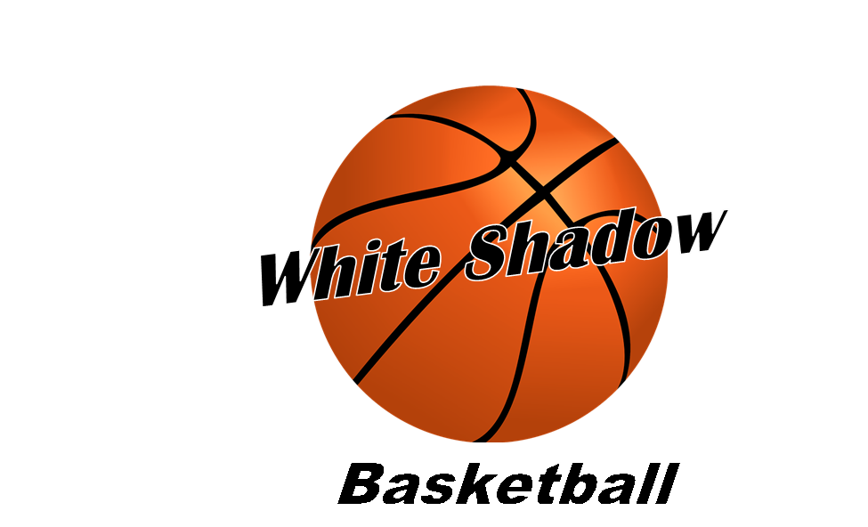

**2025 Spring/Summer Basketball Tournaments-*Updated-6/14\***

**Date Tourn. Place**

April 12th-13th United We Stand-***14U***  Westlake Ath. Center

April 19th Magic Tournament-***14U*** RR Sports Center

April 26th TWE Spring Splash- ***14U***  Georgetown/Round Rock

May 10th Magic Tourn. - ***14U***  Round Rock, Texas

May 17th TWE May Madness-***14U***  Georgetown, Texas

June 6th-8th Gym Rats Tourn.-***14U***  Georgetown, Texas

June 21st 5 Star Magic Tourn. - ***14U*** Georgetown/Round Rock

July 5th Lone Star State Championships **OR** Westlake Ath. Center

PAC Independence Classic-***14U***  Leander, Texas

***6-8 Tournaments***

***\*Note: If you can’t play on a certain weekend, please let me know by (email: whitetj@suddenlink.net or Sportsyou app) as soon as possible so I can make sure there’s enough players to play in the tournament. \****