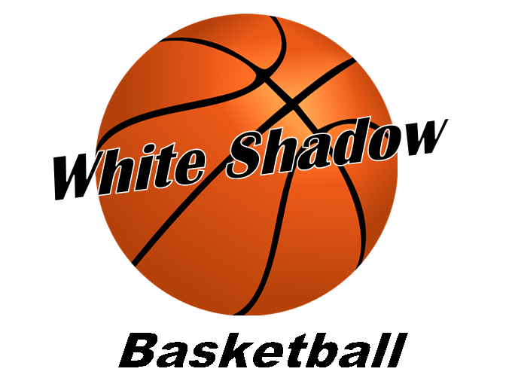
2026 Spring/Summer Basketball Tournaments-*Tentative*
Date Tourn. Place
April 4th Magic Tournament Round Rock, Texas
April 18th TXBA Eagle Invitational Cedar Park, Texas
April 25th-26th TWE Spring Splash Georgetown, Texas
May 9th Magic Tournament Round Rock, Texas
May 16th-17th TWE May Madness Georgetown, Texas
May 30th-31st Next Level-Above the Rim Classic Cedar Park, Texas
June 13th-14th TWE Summer Splash Georgetown, Texas
June 20th-21st Magic Summer Showcase Tournament Round Rock, Texas

5-8 Tournaments for each team
*Note: If you can’t play on a certain weekend, please let me know by (email: whitetj@suddenlink.net or Sportsyou app) as soon as possible so I can make sure there’s enough players to play in the tournament. *

